## How to Document As-Is, Interim, and To-Be Architectures using EMAF Artifacts using Visio (QRC)

## Introduction

All EMAF Visio artifacts can be utilized in Interim Architectures, as well as As-Is and To-Be architecture instances. The artifacts may not spell this out directly, but nothing prevents an architect from adding the architecture designator to the title and in the name of the Visio diagram tab.

This QRC provides instructions for adding the architecture instance designation in the artifact’s Title in the header and the diagram’s name.

NOTE: It is recommended that the To-Be, Interim and As-Is diagram instances are all stored in the same diagram to simplify the creation and maintenance of these diagrams.

## Instructions

### How to add an architecture designator in the artifact title?

1. If not already shown, ensure the **Shape Data Window** is displayed: Data -> Check **Shape Data Window** option

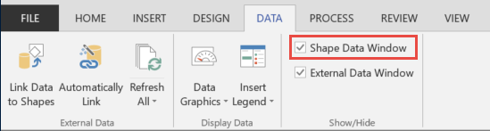

1. Click anywhere on the diagram’s header or footer to set focus (focus is shown by the handles), and the Shape Data Window will display the Header/Footer’s parameters. The Title is displayed at the top.

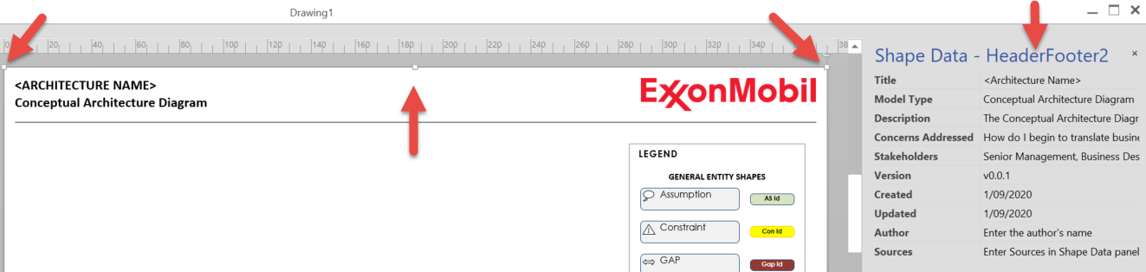

1. Click into the Title field to add the requested information, then append one of the following instance options within parenthesis “( )” and hit Enter. The title is automatically updated in the Header.
   1. As-Is
   2. Interim-n where n is the current instance number; interim numbering starts at 1
   3. To-Be

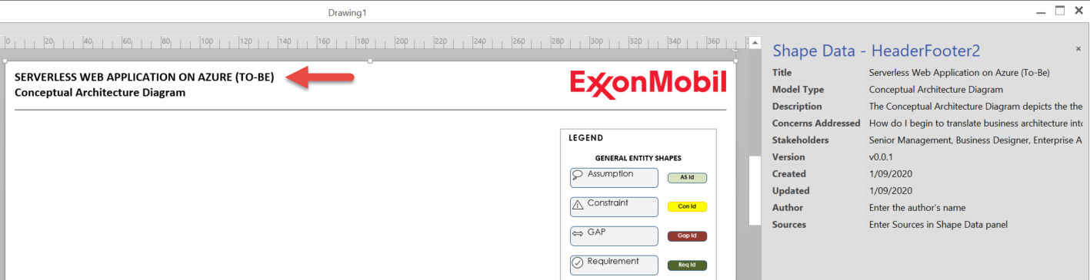

### How to add an architecture designator to a diagram’s name?

1. There are two options to rename a diagram in Visio
   1. Double click the diagram tab
   2. Right mouse click diagram tab, click **Rename**
2. Update the existing tab name, add one of following instance suffixes separated by a dash “-“ then click Enter
   1. - As-Is
   2. - Interim-n where n is the current instance number; interim numbering starts at 1
   3. - To-Be

